For Immediate Release
Contact: Ashley Curtin
Phone #617-398-5108
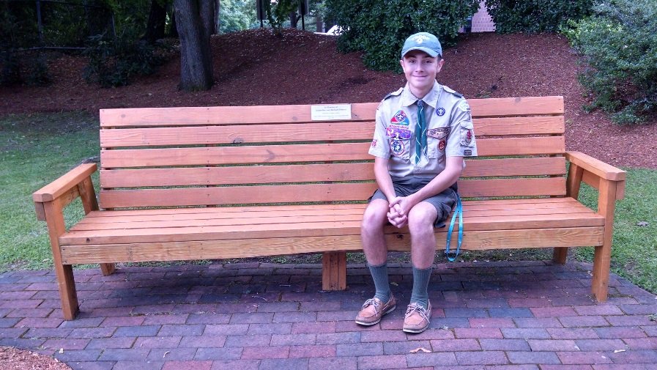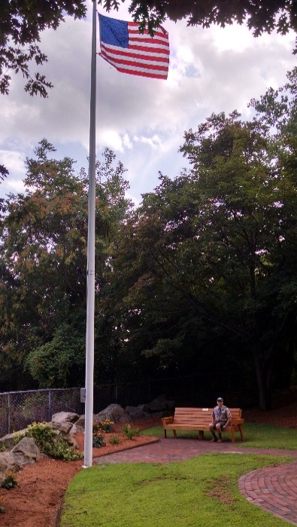

Jacqueline and Michael Thomas spent 17 happy years at Seabury Heights, a Retirement Housing Foundation property managed by The Schochet Companies in Worcester, MA, so when their grandson wanted to dedicate his Eagle Scout project to their memory, he knew exactly the most meaningful way to do it. Sean Thomas, a 17-year-old member of Troop 9, worked for months on planning, fund-raising, brickwork, weeding, planting, and building a bench in the flagpole area of Seabury Heights to honor the memory of his grandparents. On August 28, Seabury dedicated the refurbished area and celebrated Sean’s accomplishments at a ceremony which included remarks by a long-time friend and neighbor of the Thomases along with Seabury and Schochet officials and the Troop 9 scout master. Sean said he chose the flagpole area for his scout project to honor his grandfather’s service as a US Army veteran and he selected Seabury Heights because the property and its residents meant so much to his grandparents.

# # #

