For Immediate Release
Contact: Ashley Curtin
Phone #617-398-5108

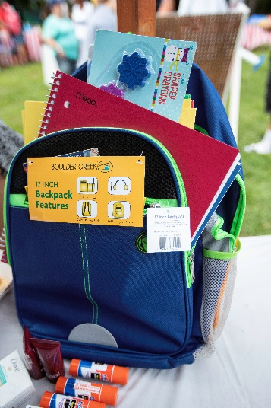
Back-To-School is reason to celebrate at RHF's Riverside Village (managed by The Schochet Companies), with great food, games, and activities at a carnival attended by more than 200 people. Elementary school children received 250 backpacks with school supplies, contributed by local residents. Participating local vendors included Leominster Community Action Team/LUK, District Attorney Joseph D. Early Jr.’s Office, WIC, Seven Hills, Digital Federal Credit Union, Mount Wachusett Community College, Training Resources of America, and Leominster Public Library.
# # #
Editor’s Note: A large selection of additional photos are available

